Even Reports: Date type data value for dhis2 2.21 vs 2.19 version
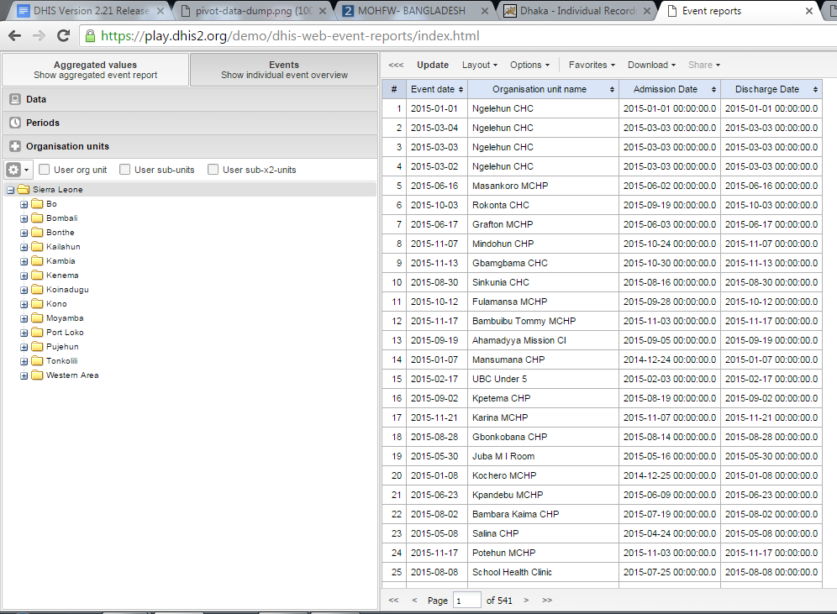
Figure: Even Reports: Date type data value dhis2 2.21 version from Sierra Leone Data
Figure: Even Reports: Date type data value dhis2 2.19 version from Bagladesh Data

