In Mozilla Firefox : (doesn’t display the ‘Data element group set’ name along-with delete confirmation message when ‘element group set’ name length is full)
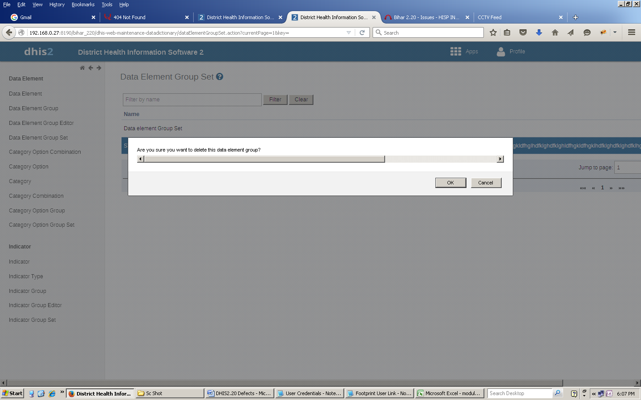

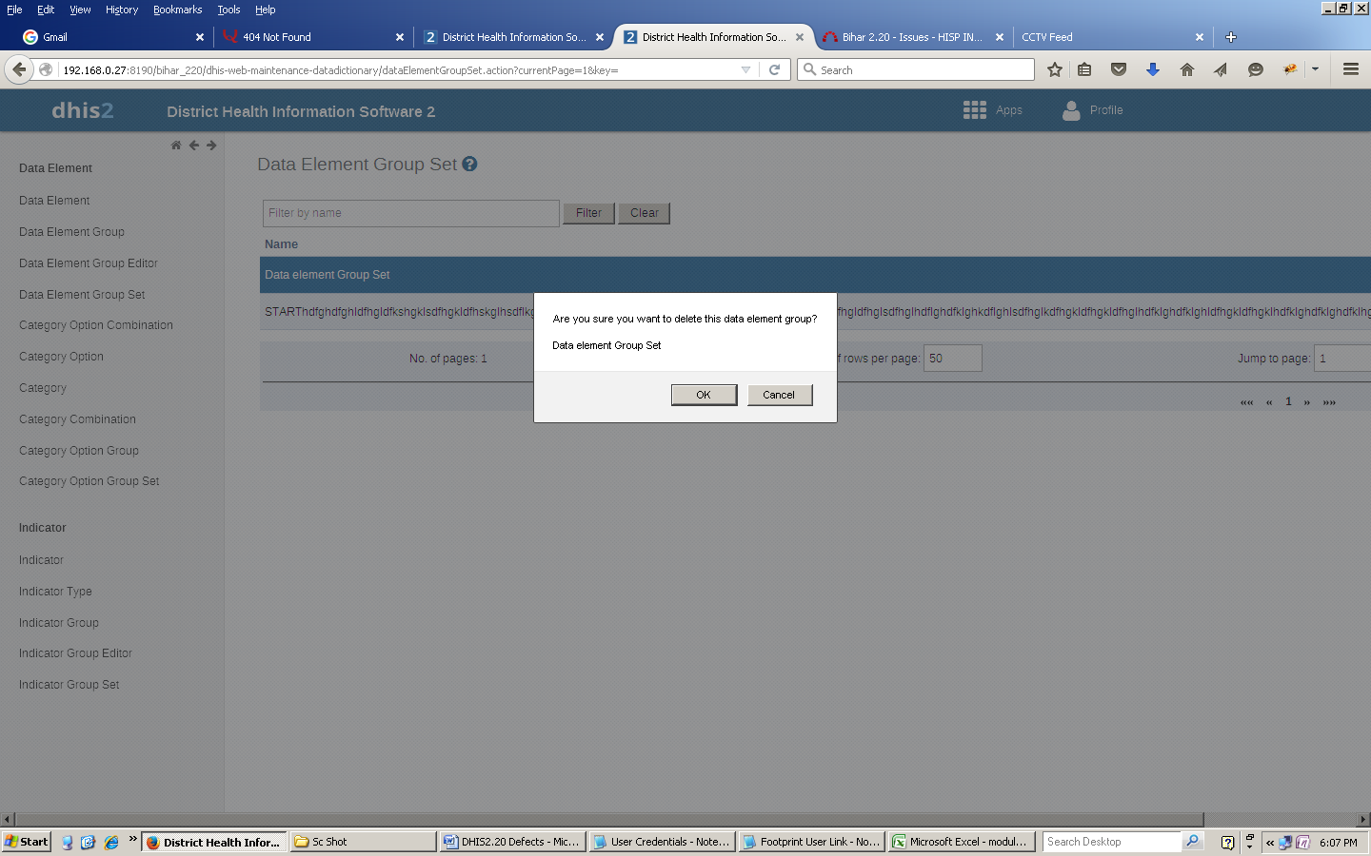

While in Google Chrome: (runs correctly)
