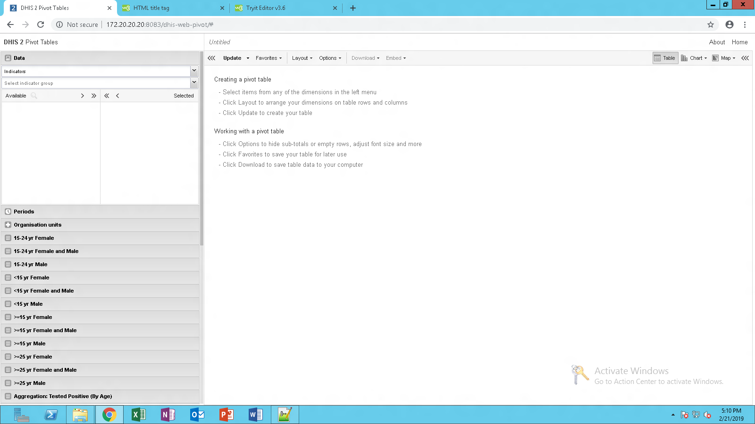

How can replace this DHIS 2 Pivot Tables by my Organization Name or Logo?