1st Step: I add one person without any specific program, after that enroll him in child program, create one event. Select new event:
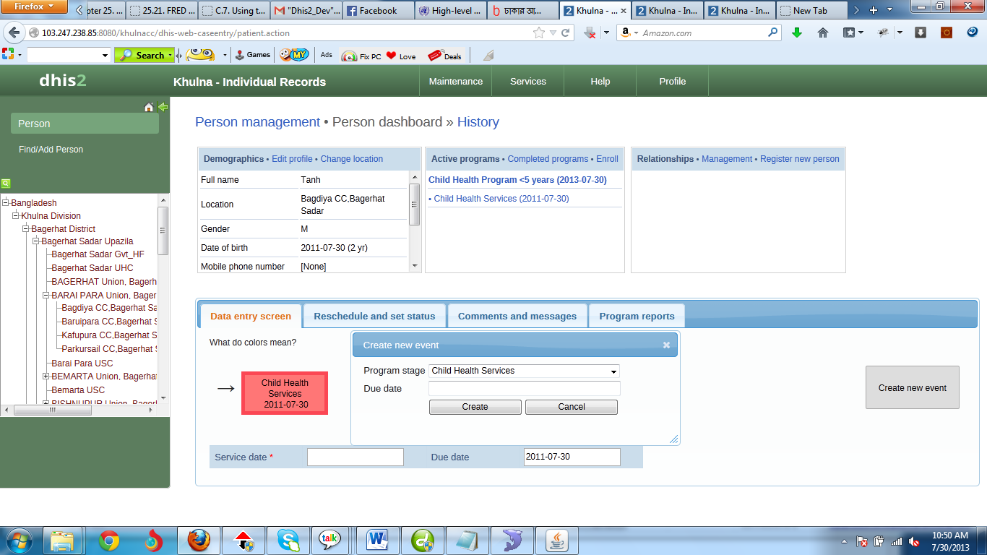
Figure: Keep the Due date empty.
Step: 2I click on create button without Due date, shows the error in bellow
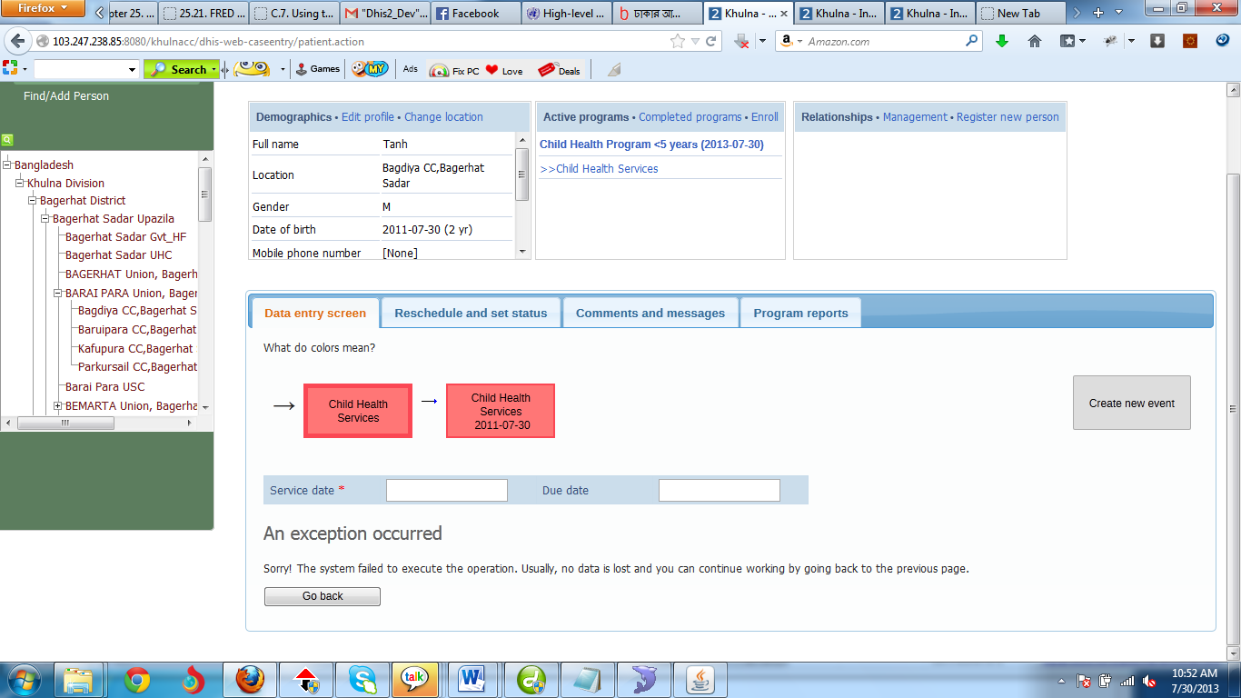

Note: If I select due date and create then it will not show any error, even when first auto generated event create that time this due date take one date.

My query : Please ensure a validation rule, if the new create event due date in emty.

