  - Screenshots guide of installation of DHIS2 live version on personal computer
16/11/2011, A. Kamugunga
The installation of all-in one live package of dhis2 that use PostgrSQL backend requires that you have a recent JRE or JDK installed (at least version 1.6 update 14), as well as a W3C compatible browser like Chrome or Mozilla. Simply download the zipped all-in-one file of dihs2-live from www.dhis2.org and unzip it to any location on your PC(ex: C:\Wspace\dhis-live) and follow the following stepwise DHIS2 set up processes
- Java installation
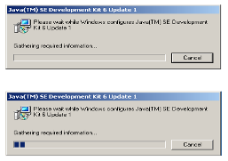 | - Dhis-live to run on a computer, need java environment. To install the java platform, double click on the downloaded exe file (jdk-6u1-windows-i586-p.exe) of DHIS2 Tools folder distributed to you.  - You can download the latest version of jdk from http://java.sun.com/javase/downloads/index.jsp.
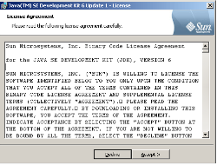 | Now a "License Agreement" window opens. Just read the agreement and click "Accept" button to accept and go further.
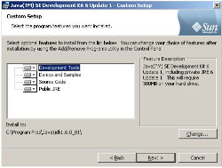 | - Now a "Custom Setup" window opens.  - You can click on "Change" button to choose the other installation directory. But in our case here , we suggest it remains as default "C:\Program Files\ Java\jdk1.6.0_01".  - Now click on Next , then"OK" button to go on.
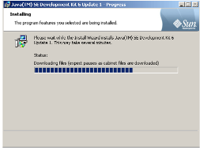 | Clicking the "OK" button starts the installation. It is shown in the left figure.
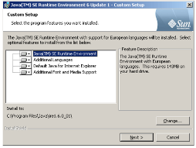 | - This window asks to install Runtime Environment.  - You can click the "Change" button to choose the installation directory of Runtime Environment. We prefer not to change it. So click "OK" button.
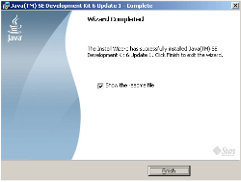 | Now "Complete" window appears indicating that installation of jdk 1.6 has completed successfully. Click "Finish" button to exit from the installation process.

- Database configuration
  - Database Management System installation(Ex: PostgreSQL)
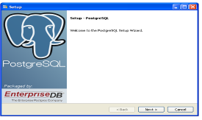 | - Double click installation executable file to get the follow screen  - Click Next
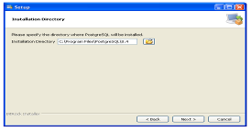 | - Choose the installation directory on your PC  - The default installation directory is usually a good choice. Then Click Next
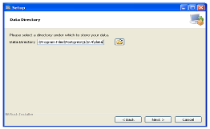 | Choose data directory
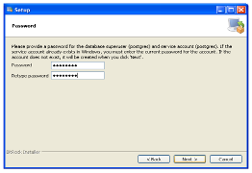 | Next you'll need to choose a password for the database superuser. Pick something that you'll be able to remember later as you'll need this to finish setting up the database to work with DHIS live. Enter the password of your choice into both password fields for user “Postgres” and then click Next.  Password: postgres
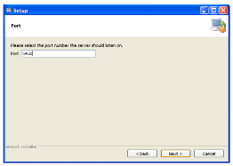 | The default port number is expected. Click Next.
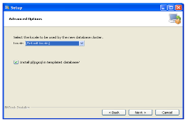 | The defaults for the advanced options are also fine. Click Next.
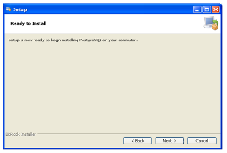 | Click Next.  PostgreSQL will now be installed. This takes a little while to finish.
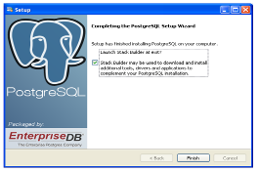 | DHIS-live doesn't need anything from Stack Builder, so the check box can be unchecked before clicking Finish.

2.2 Creation of Database for DHIS-Live
In this tutorial, the aim is to create a database “dhis2_rw” to hold data of dhis2-live into pstgresql
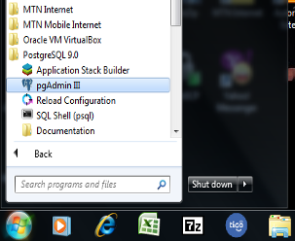 | From the start up menu, select the program “pgAdminIII” of PostgreSQL 9.0 to sign in into DBMS prostgresql.
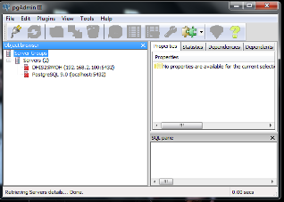 | From the left window, locate the “Servers” under “server groups” and double click on PostgreSQL 9.0(localhost:5432) to sign in
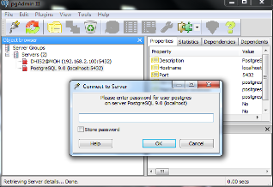 | Sign in with the password created before in this tutorial for username “postgres” . In our case password is “postgres”. Then click ok
a)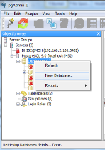b)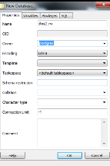 | - In the “Object browser” locate the object “Databases” and do right click  - From the top down window, Click on “New database” to create a new database for dhis-live  - Create a database “dhis2_rw” and assign it the owner “postgres”. Figure b)  - Click ok
a)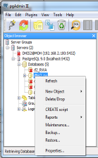b) 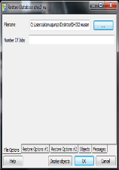 | So far the database created is empty, it has to be updated to the recent official version using a back up file.  - Right click on the database”dhis2_rw”  - From the tot down window select “restore” option to browse the back up file on your DHIS tools folder  - Browse the file ” dhis2_rwa1_november.backup” . Click ok. Figure b)
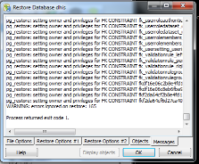 | After, the system has executed all the file, the system returns exit code 1.  And click cancel.  From now we have created database “dhis2_rw” with the latest data for our dhis-live instance

- DHIS-Live launcher configuration
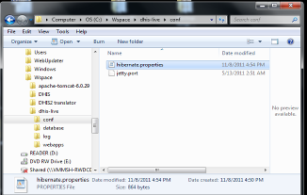 | - Locate the file “hibernate.properties” , normally located in “conf” folder. Ex: C:\Wspace\dhis-live\conf  - Open it with Notepad to insure that it connect to the database we created. In our case “dhis2_rw” . And username/password “postgres/postgres” as we created them earlier
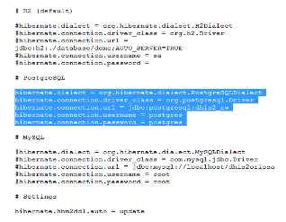 | - The contents of the hibernate.properties file would be something like this, where the database name is dhis2_rw and the user name and password are postgres.  - This file serves as connector of DHIS2 web interface to database “dhis2_rw” of our DBMS PostgreSQL
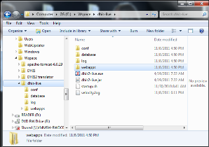 | - From dhis-live folder, locate the executable file “dhis2-live.exe”  - Right click to create a shortcut on desktop of this launcher
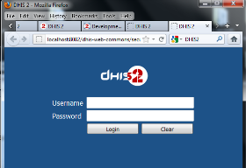 | - Here you go! Dhis-live is running on you computer on the following link  - http://localhost:8082/dhis-web-commons/security/login.action;jsessionid=18vl0txe347b41j455b1snwgmz

