I create one new Single Event Without Registration form.
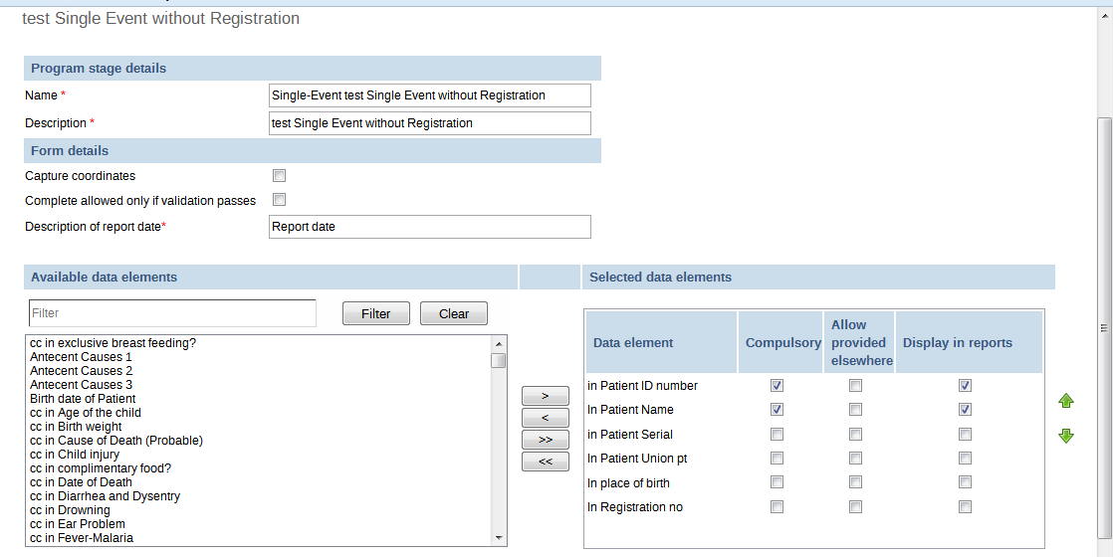
Figure: Create Program Stage
Step-2: Data Entry form.
Figure:-Data Entry Form is not coming
Background of database.
Figure: I add last single event without registration form. Error here (Capturecoord = NULL )

