Creating JasperReport/iReports with custom JDBC data source
Randy Wilson January 17, 2014
Sometimes it is difficult to create standard reports based solely on the standard outputs from Pivot Tables/Report tables. This is the case when you want to display disaggregate data by district, sub-district and health facility and when you want to report on users or user defined attributes for data elements or indicators.
In such cases you can create iReports with custom JDBC data sources. Here is the process:
- Design your report layout on paper first. Decide what data to list in the detail section, how to group the data, what totals and sub-totals you may want. | 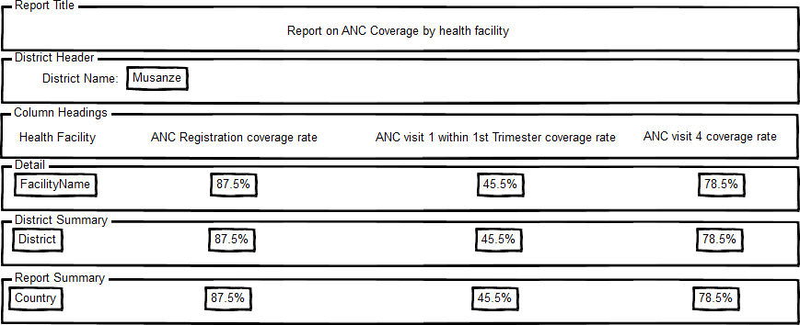
- Create and test your data query in pgAdmin III.  - Open pgAdmin  - Connect to the database that has your data  - Click on the database name to reveal the schema (e.g. HMIS).  - Once you have connected to the correct database, press the SQL icon above the object browser. | 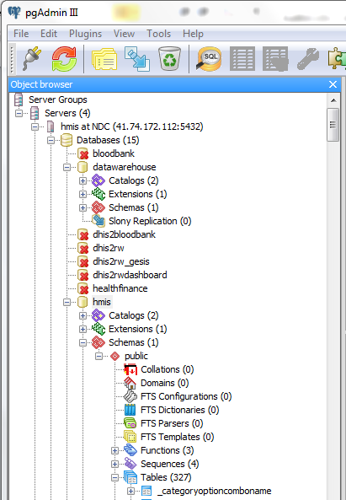
- Click on the tab to see the Graphical Query Builder.  - Open the Schemas, Public to display the tables and materialized views available | 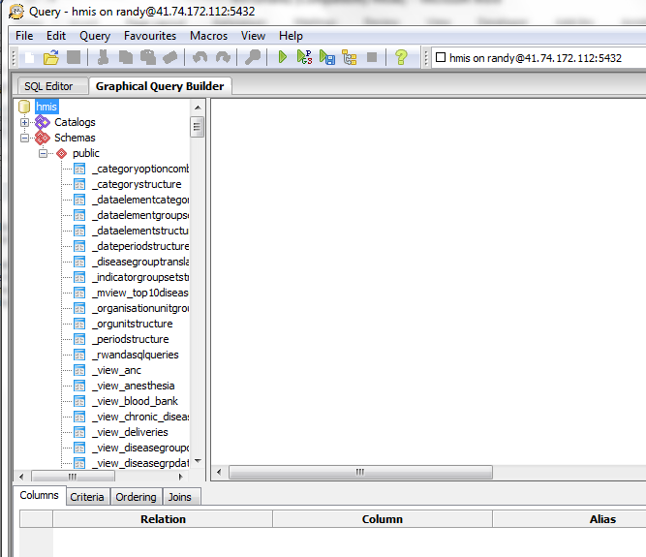
- Drag the tables you want onto the whiteboard  - Create links between the fields that link the tables using the mouse. | 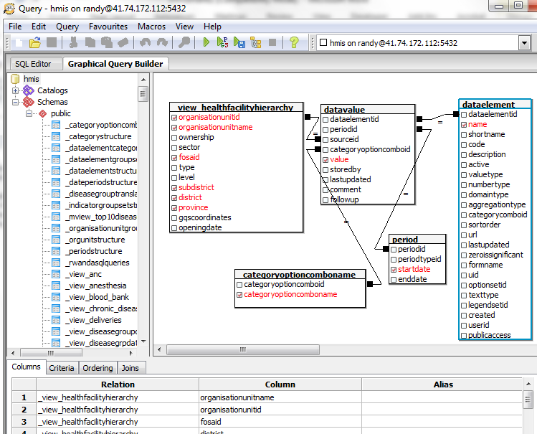
- Click on the SQL Editor tab to see the text from your query. Before testing your query, add “limit 100” to the end of the query. That way when you test it you don’t have to wait to see some results. | 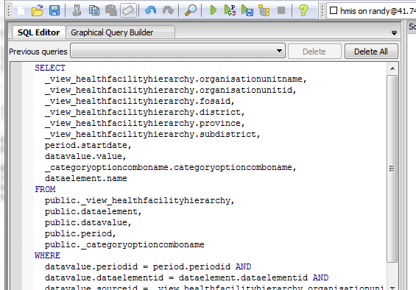
- Click on the Green arrow in the task bar to run your query
- Once you are satisfied that your query is running correctly, copy the SQL syntax (Ctrl-A, Ctrl-C) into the window’s clipboard.
- Open Jasper Studio and create a new Jasper Report (File, New, Jasper Report) using the New Report Wizard.  - Select the paper size that you want | 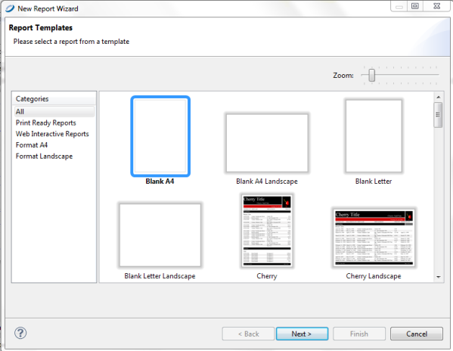
- Give your report template a name | 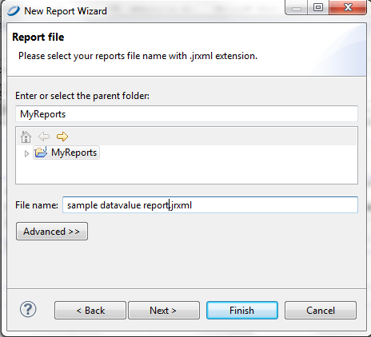
- Make sure that you have the correct “Data Adapter” selected – linked to the appropriate database with the correct credentials.  - Paste your query from pgAdmin into the database.  - Click on Next and the system will try to connect to your database and retrieve the fields. | 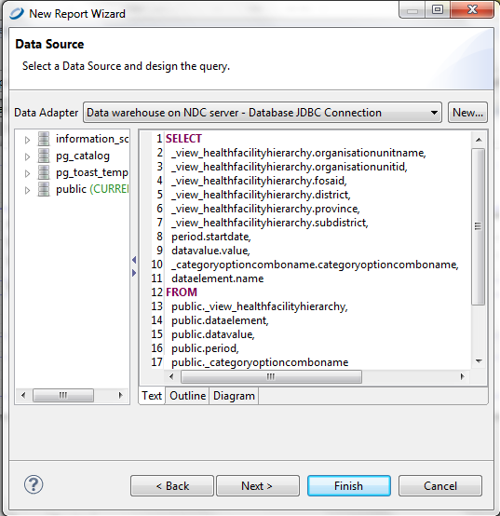
- Once you have created and tested your query, press next to select dataset fields  - Press next again for a similar dialog to select fields that you want to use for grouping data.  - Press Finish to begin arranging your fields on the design template. | 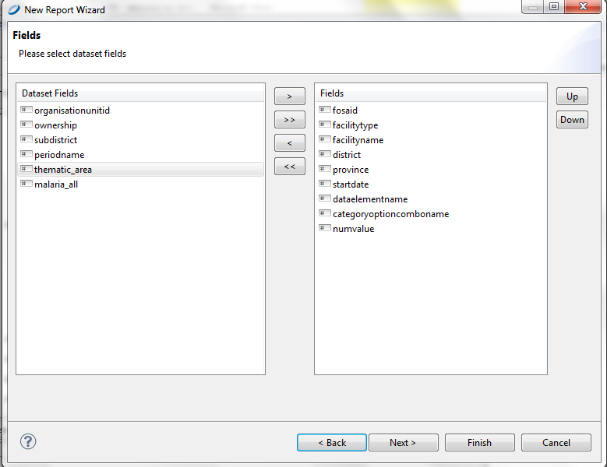
- Now a new tab should open with a blank template and you should be see the fields you need to create your report on the left. | 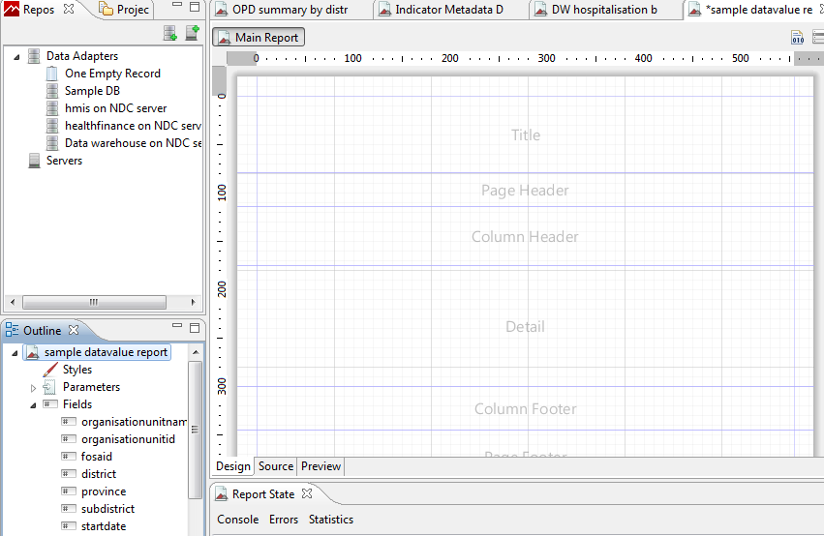
- In the panel on the lower left, click on Fields to display the fields from your query and drag them onto the report design pallet where you want them to print. Grouping fields should be placed in the group header bands while normal detail that you want printed on every row should be placed in the detail band. Note when you add fields to the detail band the field names are also inserted as column headings.  - Once you have the fields placed, you will probably want to align and size them. Select the fields and right click on one of them to show the menus for alignment, sizing and properties. (Tip: If you export a report as Excel it is important that all detail cells and their column headers are the same width as the detail fields, otherwise it creates many extra rows and columns in Excel.) | 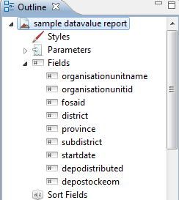
- If you used the wizard to create reports, you will probably see group headers and footers listed in the report outline window. If you want to put data on these bands, you need to right click on the header or footer and select the option to ‘Create band’. To create new data groups, right click on the report name in the Outline pane and select group | 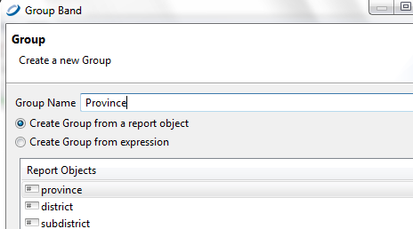
- Test your report by clicking on the preview tab.  - Once you are happy with the format of your report, save it as a .jrxml file that you can import into DHIS-2. | 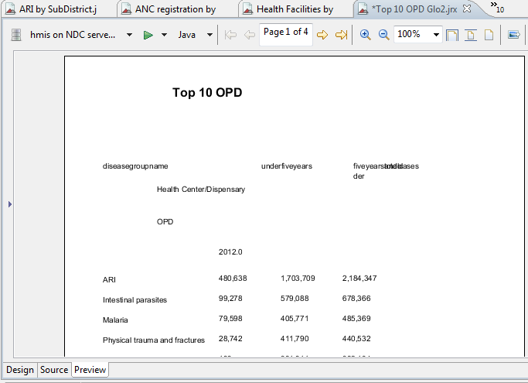
- In the create new report dialog, enter a name for the report, chose Jasper report with JDBC data source, Choose the .jrxml file that you have saved and then indicate the report parameters that you want your users to select if you have used parameters. | 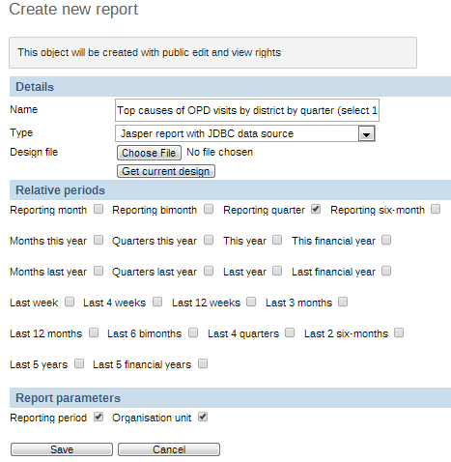
- Test your report by running it from the DHIS-2 Standard Report list. Note: if you want to modify the report layout in JasperReports, make sure that you save the revised layout and edit the Starndard report again, choosing the new .jrxml file. Otherwise it will continue to display the old report format | 