Health Information Systems Program Uganda
DHIS2 Training Module 2
End of Course Exam

Section A: Organization Units

- Using the training Server, under HISP Uganda, create a country named your Name (Eg. Jackson)
- Under your newly created country, build the organization unit structure for the table below

Facility Name | Region | District | Ownership | Level
Mulago NRH | Central | Kampala | Government | NRH
Kiswa HC | Central | Kampala | Government | RRH
Nakasero Hospital | Central | Kampala | Private | Hospital
Palgon Hospital | Central | Kampala | Private | Hospital
Gulu RH | North | Gulu | Government | RRH
Apeke HC | North | Gulu | Government | HC III
Peace Hospital | North | Gulu | Private | Hospital
Aguru HC | North | Gulu | Private | HC IV
Mbarara RH | West | Mbarara | Government | RRH
Kamukuzi Med Center | West | Mbarara | Private | Clinic
Ruharo HC | West | Mbarara | Government | HC III
Mbarara West HC | West | Mbarara | Private | HC IV

- Create all the groups and groupsets provided in the table and assign respective orgunits.

Section B: Data elements and Data sets

World Vision has been provided grants to implement a Child and Mother Project in all the health facilities in section A. As a requirement all implementing facilities will be submitting monthly reports on the key project data elements in the report below.

- Design a DHIS2 CUSTOM entry form to facilitate entry of the monthly reports from all the facilities.

Child Mother Project Report

Part A: Child Immunization
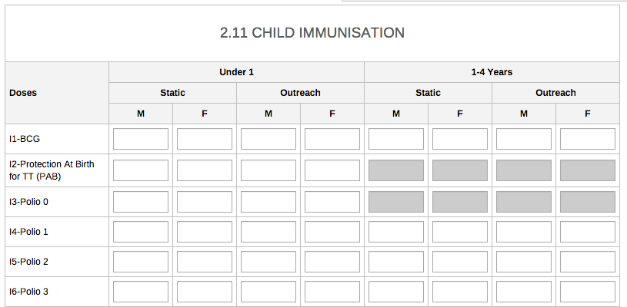

Section B: Mother
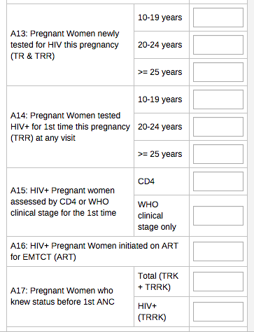

Section C: Data quality, entry and basic analysis

- Add a data validation rule to validate A13 and A14. (Totals in A14 should be equal or less than totals in A14)
- Create a surveillance rule to alert all the PMTCT coordinators whenever more than 40 HIV + pregnant women are initiated on ART for EMTCT
- Create different district-based user accounts for each districts and use each district account to enter dummy data using the months with tickets (✔)

Facility | Jan | Feb | Mar | Apr | May | Jun
Mulago NRH | ✔ | ✔ | ✔ |  |  | ✔
Kiswa HC |  |  |  |  |  | ✔
Nakasero Hospital | ✔ |  | ✔ | ✔
Palgon Hospital |  |  |  |  | ✔
Gulu RH |  |  | ✔
Apeke HC |  |  |  |  |  | ✔
Peace Hospital | ✔ |  | ✔ |  | ✔
Aguru HC |  |  |  | ✔
Mbarara RH | ✔
Kamukuzi Med Center |  | ✔ |  | ✔ |  | ✔
Ruharo HC |  |  |  |  | ✔
Mbarara West HC | ✔ |  | ✔ |  |  | ✔

- Using reports app, answer the following questions. (Please take screen captures and add then in your word report documents)
  - How many facilities reported by region for January 2015
  - How many private facilities reported in June 2015
  - How many facilities are private
  - Upload you answer sheet under resources and save it by your names

Section D: Tracker – Events and Programs

A. As part for the Data quality improvement project run by Ministry of Health, on annual basis, all facilities are supposed to be assessed using the following assessment tool.

Using the program without registration design an assessment tool to capture the assessment data from all facilities

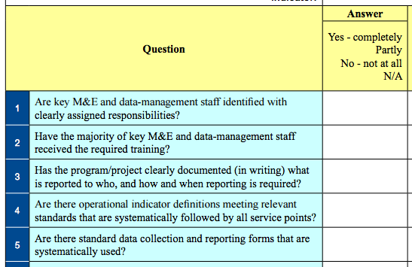

B. The department of department of Child Health would like to improve Immunization by tracking child immunization every month. You have been requested to design a DHIS2 tracker program that register children and tracker key immunization

Using the program WITH REGISTRATION design a tracker program that will register children and tracker them every month.

Registration should include the follow
- Child number
- Child date of birth
- Child sex (Male/Female)
- Care giver phone number

For every month the following will be collected
- Date of visit
- Weight of the child
- Heath of the child
- Immunization provided (DPT/Polio/Measles)

