Leishmaniasis surveillance in DHIS2 : how to calculate an accurate incidence ?

Context
Leishmanaisis is a very focal disease. Diagnosis and treatment is not easy, and in endemic countries, only few health facilities are able (well-trained health workers + material) to perform proper diagnosis and case management.
To be able to accurately map the distribution of cases and accurately calculate incidence and population at risk, the cases need to be allocated to the probable place of infection (or at least the place of residence), and not to the place where they are treated.

Use case
Let’s take the example of visceral leishmaniasis in Somalia. Currently, only 3 health facilities are able to diagnose and treat VL patients in Somalia. Two in Bay region, and 1 in Bakool region.
Since 2013, Somalia is capturing individual data for all VL cases in those 3 VL treatment sites using a simple spreasheet. We imported through an Excel importer App all thoses individual data into a Program without registration (Event).
All the patients are therefore assigned to the VL treatment site where they were treated and reported. Their place of residence is captured in the form.
We created a program indicator (PI) to calculate the « total number of VL cases ».
When using the usual aggregation from DHIS2, all the VL Cases are then aggregated into two regions, Bay and Bakool, which are the region of the 3 registering org units.
We would like to produce a table of the aggregated number of cases by village level, so that the cases will aggregate on the district and region of residence/infection, rather than on the place of treatment. This will enable to calculate accurate incidence and population-at-risk at district and region level.

Objectives

Main objective
To allocate and aggregate the VL cases based on the probable place of infection (or, as a proxy, the place of residence), and use this aggregated number to calculate incidence and population at risk (which is not possible to our knowledge if using capture coordinates)

Secondary objective
To map cases at village level (which is already possible if using capture coordinates)

Methods

(Enter villages as organisation unit)
This step is not mandatory for the main objective which is to be able to allocate VL cases to district of residence and then calculate accurate incidence and population at risk.
However, it is useful for mapping at village level and this is the level of details we wanted to reach for Somalia.
We therefore search different geodatabases available on the web. After comparing the different geodatabases, we exported name and coordinates of XXXX villages in Somalia, and imported them as org units in the org unit tree of Somalia which therefore contains the following :
Somalia > Region > District > Village > VL treatment site

Capture village (or district) as org unit
We created the program without registration « VL register ».
We created a data element of type « org unit » to capture the place of residence at the finest level available.
If the village could not be found in the org unit tree, the district or region of residence was captured through this DE. The village could then be captured by two other options : 1/ by opening the map of the « coordinates » type DE and searching for the village ; 2/ by typing the name of the village as text.
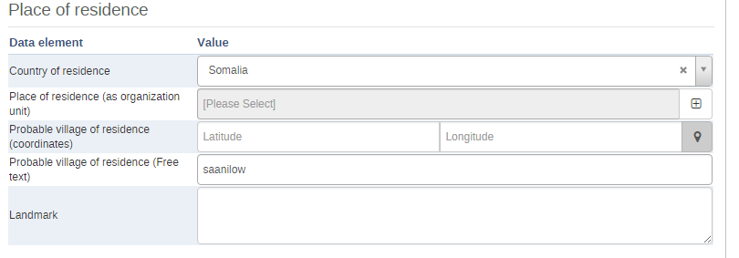

Duplicate the program and reverse the org unit tree
A script was written to duplicate the program « VL register », rename it « VL register – from village » and reverse the org unit tree.
The village of residence, captured as org unit in the form of « VL register » became in « VL register – from village » the registering org unit.
In the duplicated program « VL register_From village », not all the DE were captured, only those of interest to calculate incidence and population at risk (gender, age, type of patient, origin of patient).

Results

Aggregated number of VL cases at regional level
In the Table X, is represented the number of VL cases at regional level, by using the default org unit related to the program « VL register ».
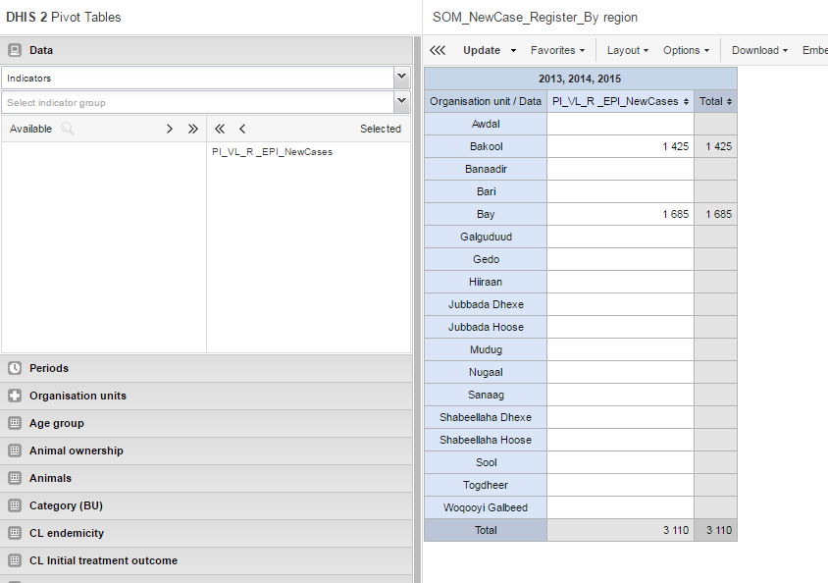
We see than all the cases are aggregated in Bakool and Bay region.
If we produce the same table, but using the program « VL register – from village » (i. e. the village of residence as registering unit), then the cases are aggregated on the place of residence, and the aggregated number of cases is spread across X regions (Table X).
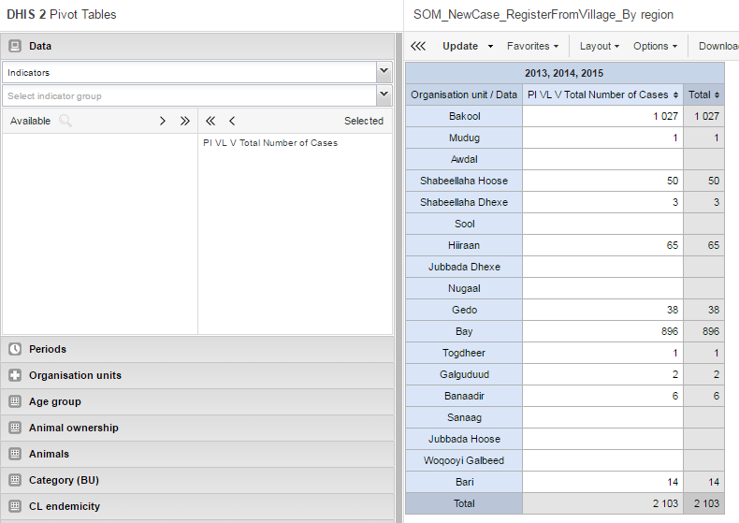
Retrospectively, only 2013 cases could be allocated at village level.

Incidence and population at risk, at regional level
This therefore enable to calculate accurate incidence (number of VL cases coming from an IU / population in the IU * 10’000) and population at risk (population leaving in endemic IU).

Mapping of the cases at village level
The number of VL cases can be mapped at village level by using program indicators.
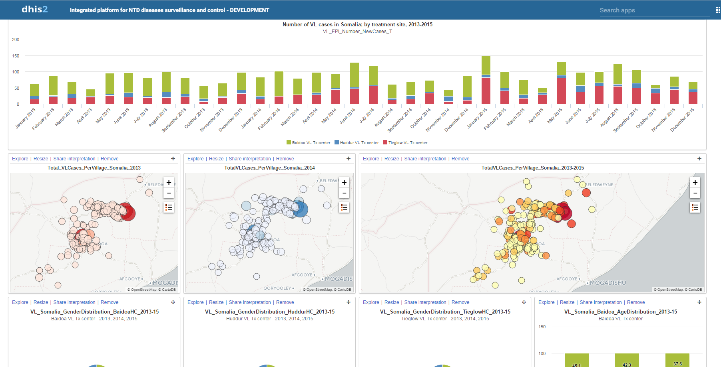
However, some of the features from “Event layer” are lost (clustering, display of several information for each dot…).

Discussion

Strength
- Enable accurate calculation of incidence and population at risk, based on place of residence/infection and not on place of treatment.
- Enable mapping the cases at village level.

Challenges
- All villages have to be entered as org unit (but this is optional for main objectives)
- Usually, a user from a health center will only be given access to his/her health facility for data capture. But if we do this, then they have access only to their health facility in the org unit tree of the DE…
  - We therefore gave access to all Somalia to the users, but therefore they have to look for their own treatment center -> ideally, we should be able to specify was is visible for this secondary org unit tree.
  - There is no possibility for search an org unit in the org unit tree of the DE -> implementing a search option will ease the data capture.
- Org unit type DE are not available for the moment for the analysis
  - We therefore had to develop this script to duplicate the program and reverse the org unit tree (With the help of Jason) -> It would be better if in the core version of DHIS2 we could should to analyse the data through this secondary org unit tree.
- By using the org unit type DE and not the coordinates type DE, we lose some very nice features on GIS for Event layer (clustering, filtering, displaying information when clicking on a village…)
  - However, the coordinates are attached to the org unit selected in the org unit type DE -> If would be ideal if we could allocate Latitude and Longitude to coordinates type DE when a village is selected in the org unit type DE.

