Create New Event with “Report Date” (Date of Event) as 2015-10-05
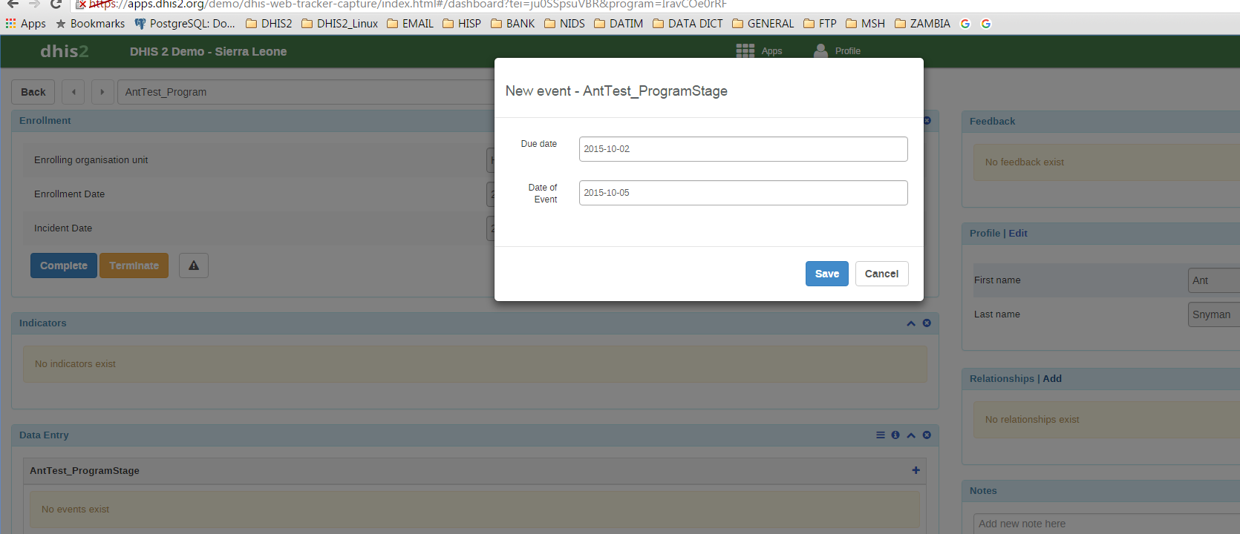
Initially it creates is correctly as the date was entered – 2015-10-05
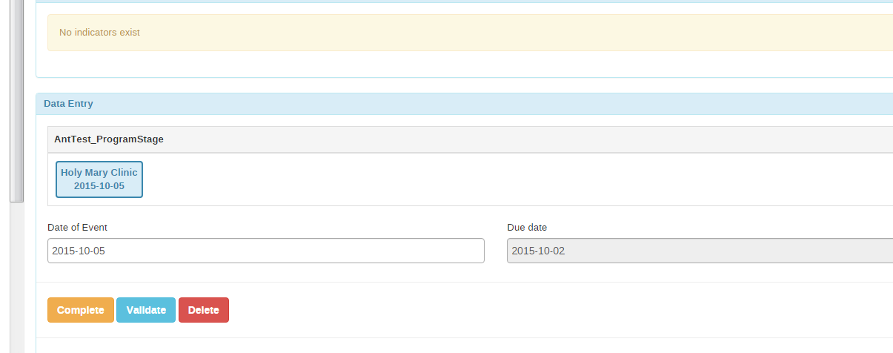

When the screen is refreshed, or you go “Back”, select the trackedentity again to look at the events, then the date displays as 1 day less – 2015-10-04