We are using dhis2 2.13 version in our Tracker server.
We have a program name COIA Child Tracker; it has 2.13 version default attributes (Full Name, Gender, Date of Birth and so on.). Additionally, we have few more Patient Attributes with predefined attributes value (Valid, Not Taken and so one.)
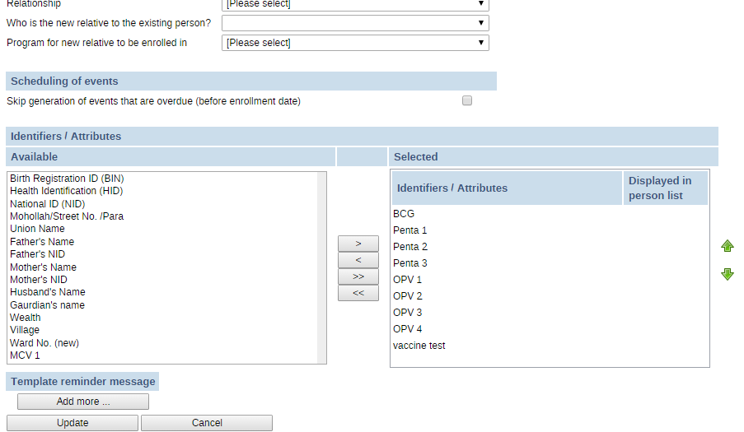
This program tracking Child working fine and saving it’s all attributes value perfectly. Suddenly it is not saving its patient attributes value. When I add Patient with predefined attributes It is not saving PatientAttrivutesvalue
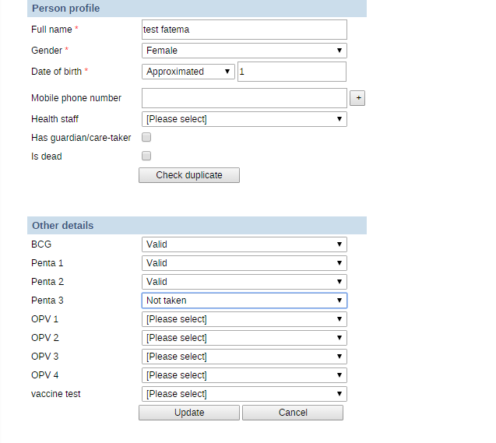
Go to Patient Dashboard Identifier Attributes Its shows no value saved
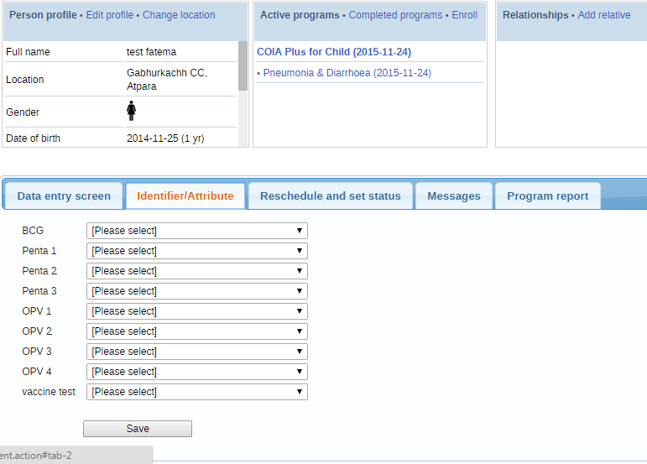
When I add value in Patient Dashboard Identifier/attributes, Few value saved successfully
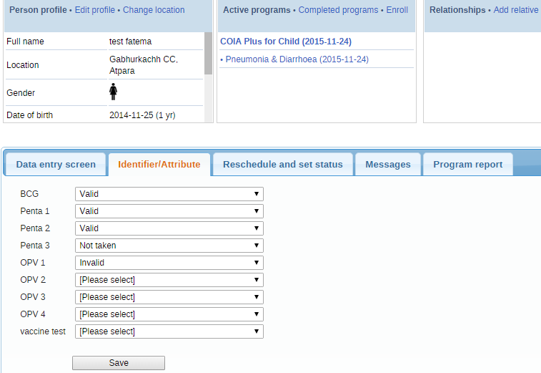

When go again to Patient Profile Update it shows value
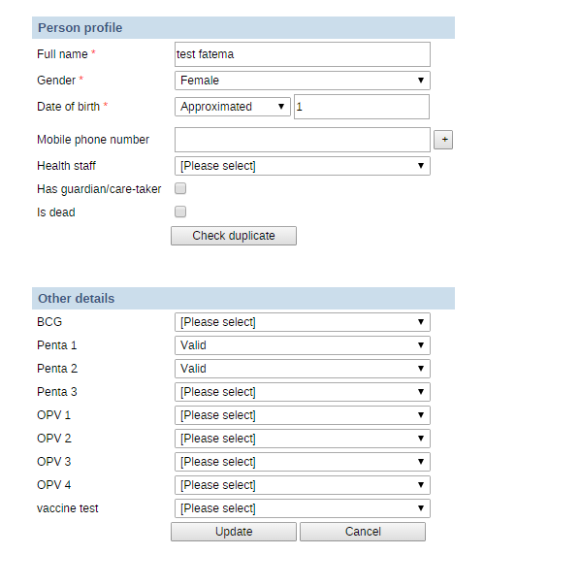

Again I update the patient profile It deleted this saved data also
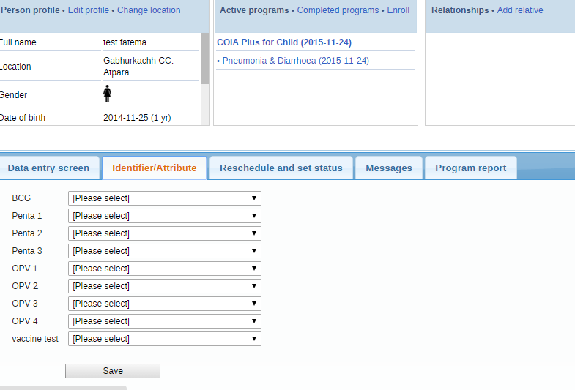
Log shows error when update profile
* INFO 2015-11-24 15:47:43,267 Deleted objects associated with object of type P
atientAttributeValue (DefaultDeletionManager.java [http-apr-8085-exec-9])
* INFO 2015-11-24 15:47:43,267 Deleted objects associated with object of type P
atientAttributeValue (DefaultDeletionManager.java [http-apr-8085-exec-9])
* INFO 2015-11-24 15:47:43,267 Deleted objects associated with object of type P
atientAttributeValue (DefaultDeletionManager.java [http-apr-8085-exec-9])
* INFO 2015-11-24 15:47:43,283 'admin' update org.hisp.dhis.patient.Patient, na
me: test bayby, uid: UwmYpgQDkvK (AuditLogUtil.java [http-apr-8085-exec-9])

Additionally log is attached here

