Version 2.14 – build 13815
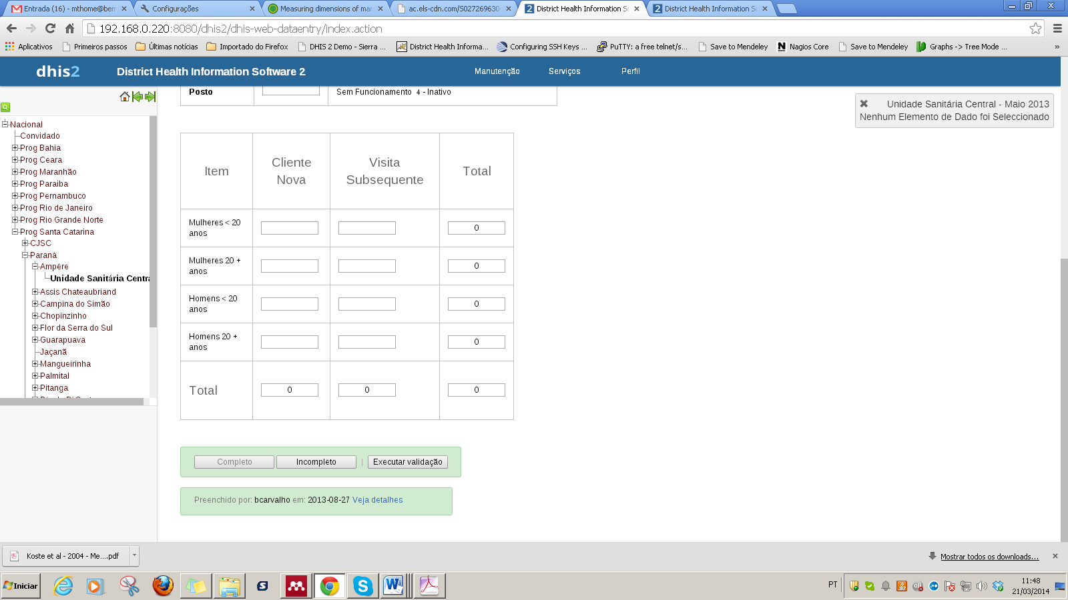

Version 2.11 – build 10550
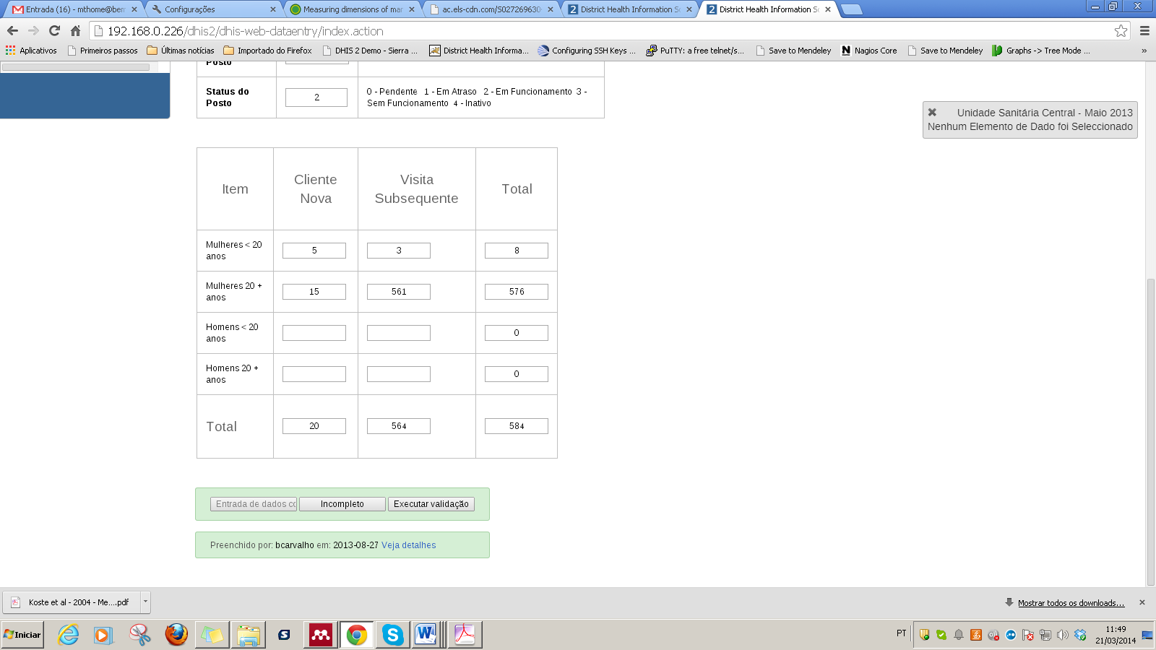

Version 2.14 – build 13815
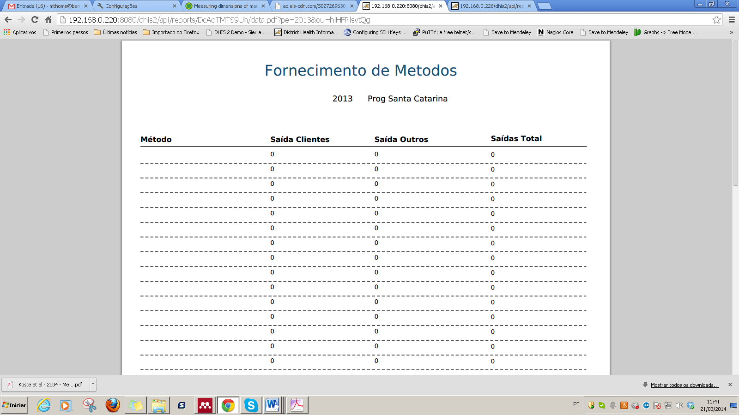
Version 2.11 – build 10550
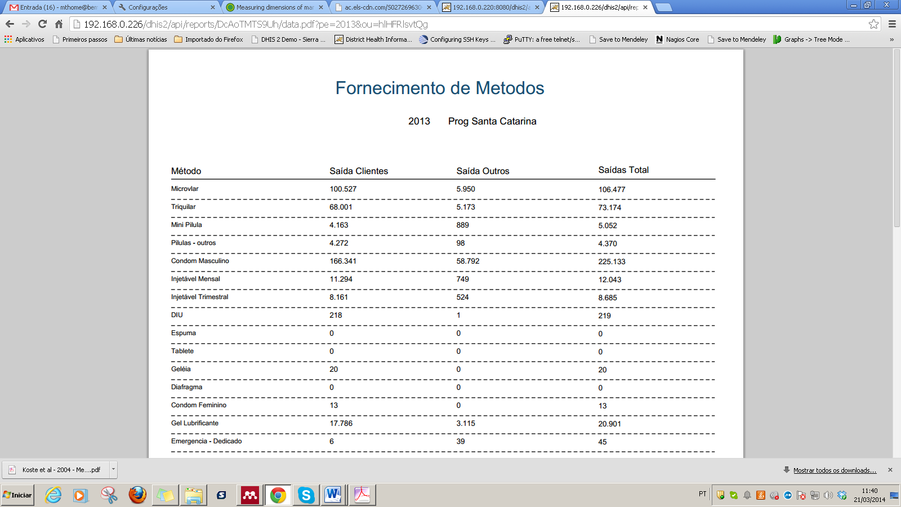

Version 2.14 – Build 13815 - Error in Analytics
