Problem 3
Search option is not working.
When we put a name (this case MITA) in the filtering with a name it still showing the same result and showing ‘you have active filter’ but the name s are not filtered.
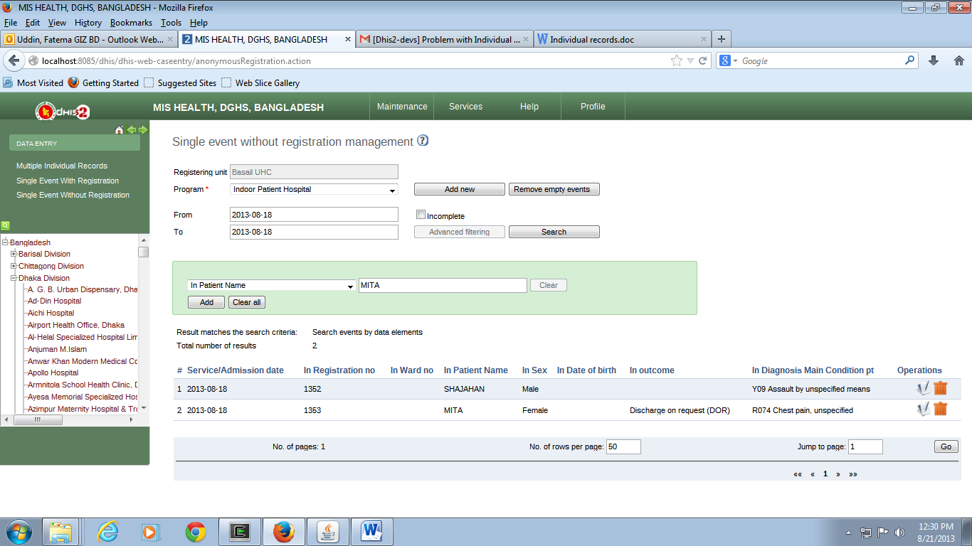
After editing single event without registration form. Entry screen is not coming.
Database table programstage column capturecoord (Highlighted column) is not updating (it should FALSE). This is the cause of previews error.

