# Community Health Worker Logistics Management Using DHIS2 – cStock Kenya Project

## Background

In 2011 JSI introduced cStock mHealth tool for community health worker (CHW) logistics reporting in Malawi. CHWs in Malawi manage a supply of 19 different lifesaving commodities, but struggle with frequent stockouts. The goal of cStock system is to enable CHW, using simple text messages, to report monthly stock-on-hand and resupply of commodities. This data would then be used to automatically calculate consumption and resupply values which would be automatically pushed to CHW supervisors. The result of this was a 14% reduction in stockouts or low stock levels, increased supply chain reporting rates, and decreased time between requesting and receiving products.

## DHIS2 for cStock

Despite its successful uptake in Malawi, cStock still faced challenges with scaling to new countries. The cStock systems had been built using highly customized, proprietary software. While being tailored for the Malawian context the software was not able to be easily adapted to a new country context. Furthermore, the cStock data was not able to be exchanged with other national information systems like the Health Management Information System (HMIS) and Logistics Management Information System (LMIS). Because of these limitations, JSI, decided to utilize DHIS2 for the adoption of the cStock system in a pilot in Kenya. JSI choose DHIS2 because it was able to accommodate the cStock reporting requirements, indicator calculations, and analytics and feedback requirements in a generic manor that would also align with other national information systems and reporting procedures.

The cStock project in Kenya utilizes both DHIS2 aggregate data capture for routine monthly stock on hand and resupply as well as tracker capture for reporting and tracking stockouts. The cStock workflow is presented below.

A close up of a map

Description generated with very high confidence

cStock Reporting Tools

The cStock project required that all reporting be enabled through SMS short code. This means that CHWs can report aggregate monthly data via SMS but also tracker, stock out data via SMS also. Additionally, the Ministry of Health in Kenya required that CHWs also be enabled to report all data via android application also. Therefore, CHWs were trained in both SMS data reporting as well as use of the generic DHIS2 android apps for reporting.

SMS reporting example

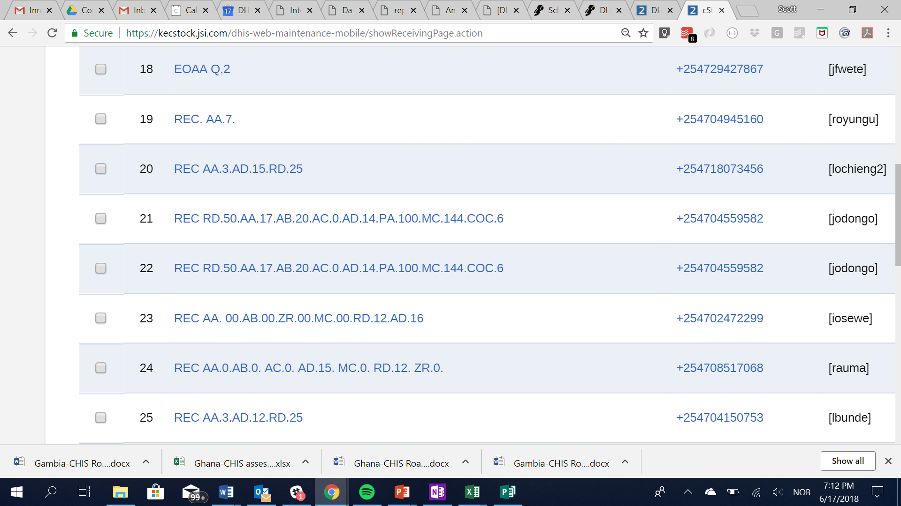Aggregated data set reporting – Receipt

A screenshot of a cell phone

Description generated with very high confidenceA screenshot of a cell phone

Description generated with very high confidence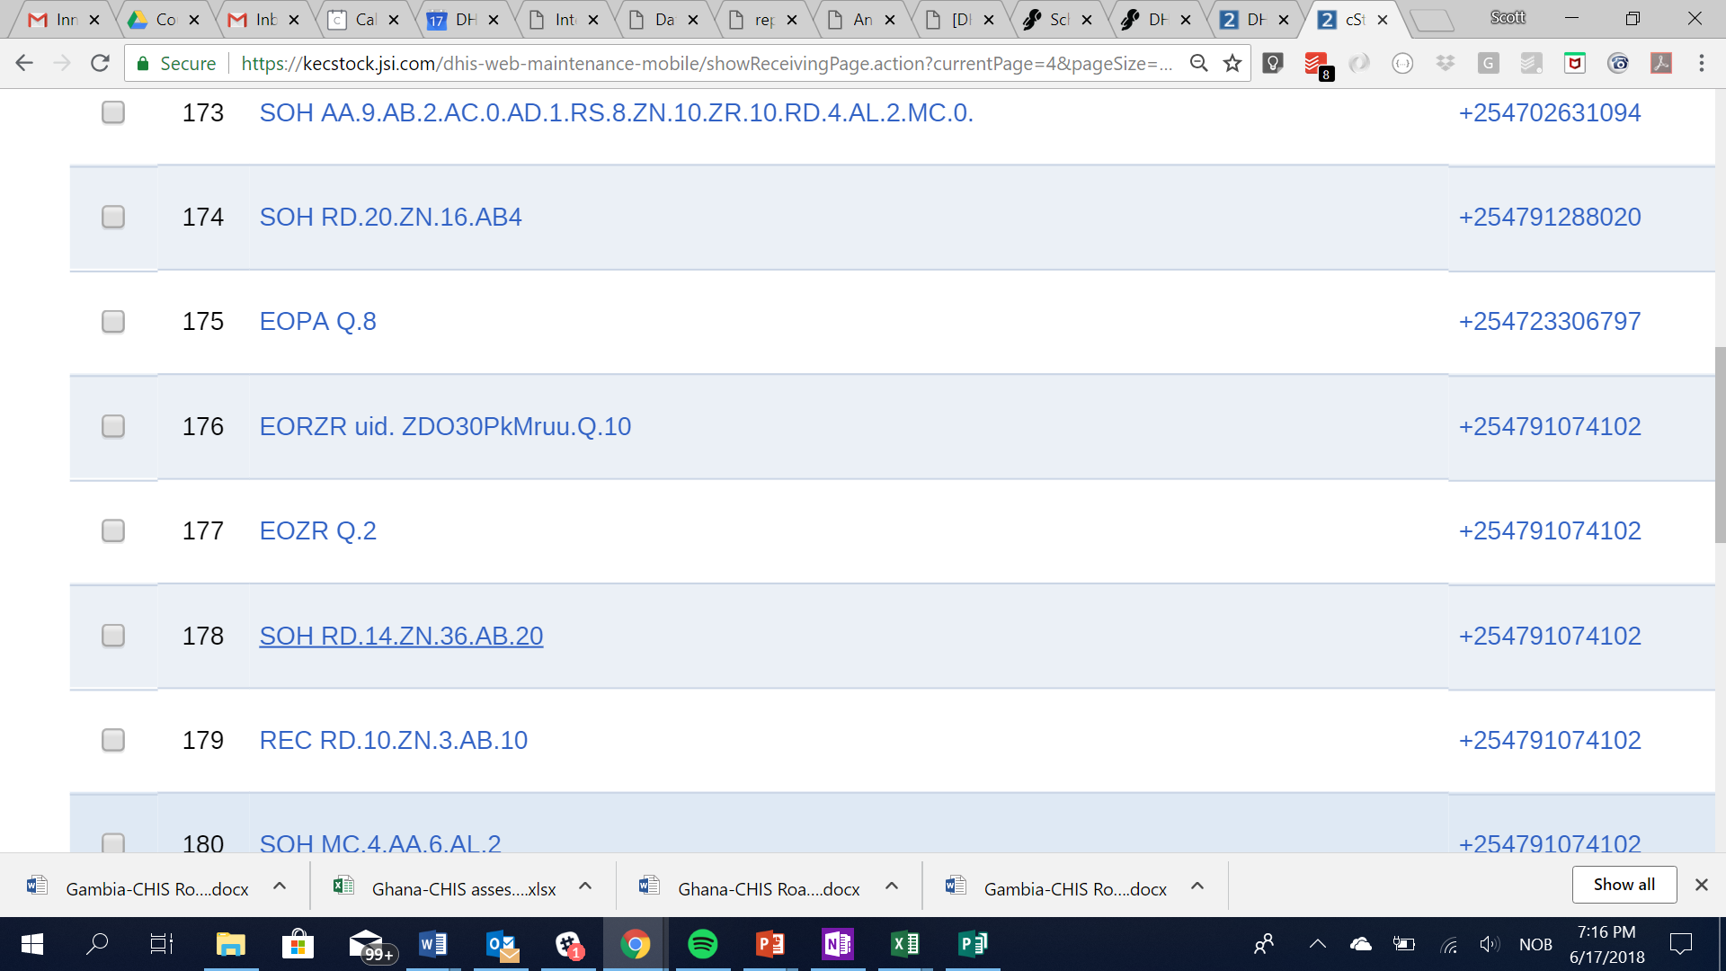Tracker Reporting – Emergency Order

Mobile Reporting Aggregated data set reporting – Stock on Hand

Mobile Reporting Tracker data capture – Emergency order enrollment

## cStock Indicators

The cStock project required several complex indicators. These indicators all incorporated previously reported data and were therefore calculated using DHIS2 predictor feature.

The indicators are:

* Previous stock on hand (copy from last month)
* Average monthly consumption (past 2 months)
* Resupply = 2 x Average monthly consumption

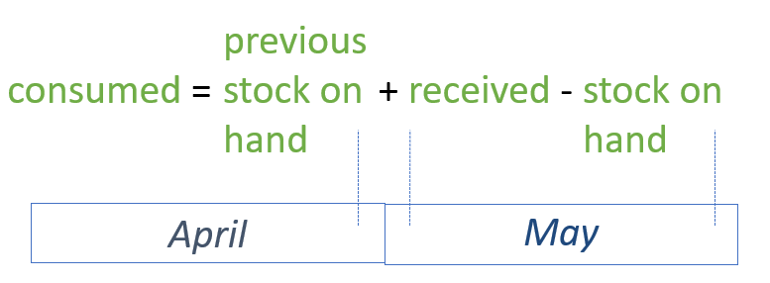

* Stockout days starting last month (copy from last month)

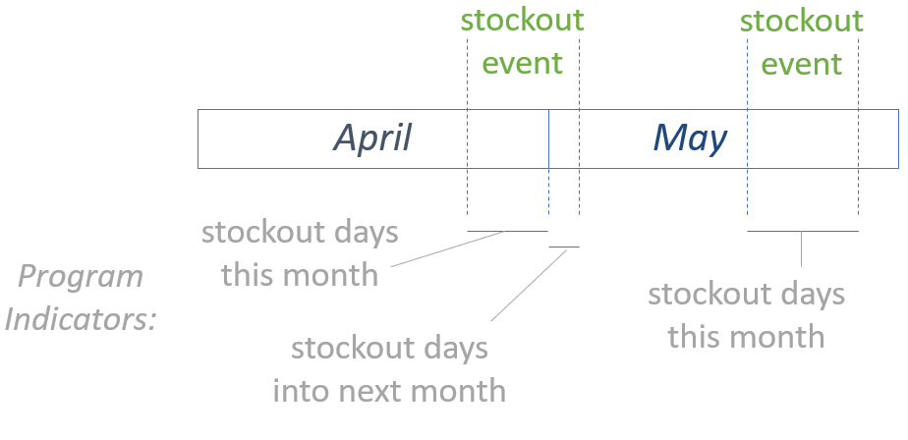

* Stock status: Stockout Stock on hand value = 0
* Stock status: Understocked Stock on hand value > 0 to .5 * consumption stock
* Stock status: Adequate Stock on hand value > .5 to 2 * consumption
* Stock status: Overstocked Stock on hand value > 2 * consumption

## cStock Analytics

Standard cStock dashboard have been developed for CHW, CHW supervisors, and district health officers. These dashboards are made using relative period and organizational using selection. Users with the same programmatic roles (CHW, CHW supervisor, etc) are grouped into respective user groups. Then their standard dashboard is shared with the user group that corresponds with the same user group. This enables all users to have dashboards that reflect their organization units they are assigned in DHIS2. The dashboards are able to be viewed by CHWs and their supervisors via the DHIS2 android dashboard application.

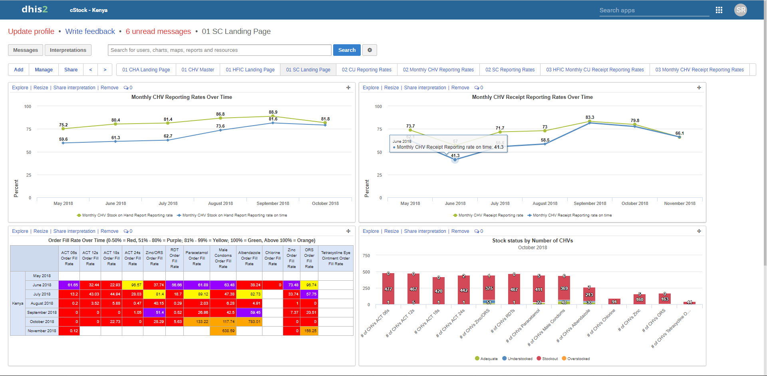District Health Officer cStock dashboard:

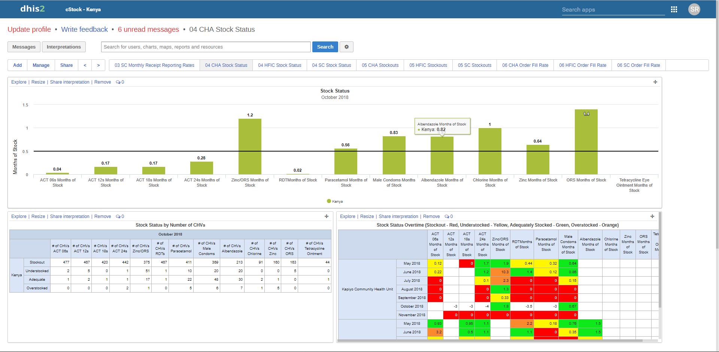CHW Supervisor cStock dashboard:

## Key Findings

From the pilot it is clear that CHWs face systematic challenges with maintaining an adequate quantity of stocks. The cStock system in DHIS2 was developed under the assumption that CHW would typically have some supply of stock on hand for all commodities and that stock-outs, although frequent, would be addressed in a timely manner. Unfortunately, the data shows that commodity stockouts are often perpetual. Going forward this fact must be considered for system design and indicator calculations.

Still, despite shining a clear light on the severity of CHW commodity stockouts, the cStock pilot has shown that DHIS2 is suitable for capturing CHW commodity data and producing required indicators and analytics in a generic way without requiring any custom scripts or applications.

The cStock project has also heavily influenced the core DHIS2 development roadmap. Specifically, cStock has resulted in:

* Improved predictors that include both aggregated and tracker data
* Improved android applications for reporting stockouts and low stock levels
* Improved permissions in tracker that limit a single user to a single stage
* Batch predictors
* Adding if and isnull functions to predictors.
* Improving SMS aggregate and tracker data capture.