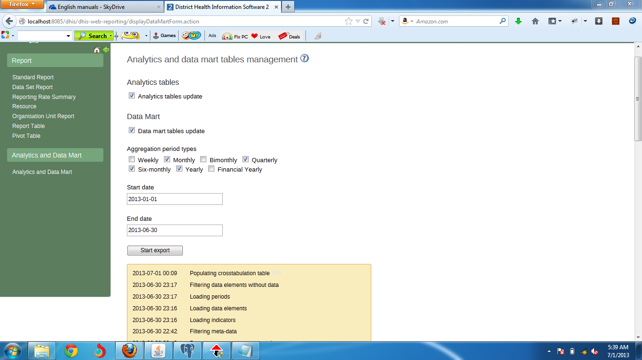Figure: Still in Populating Crosstabulation Table
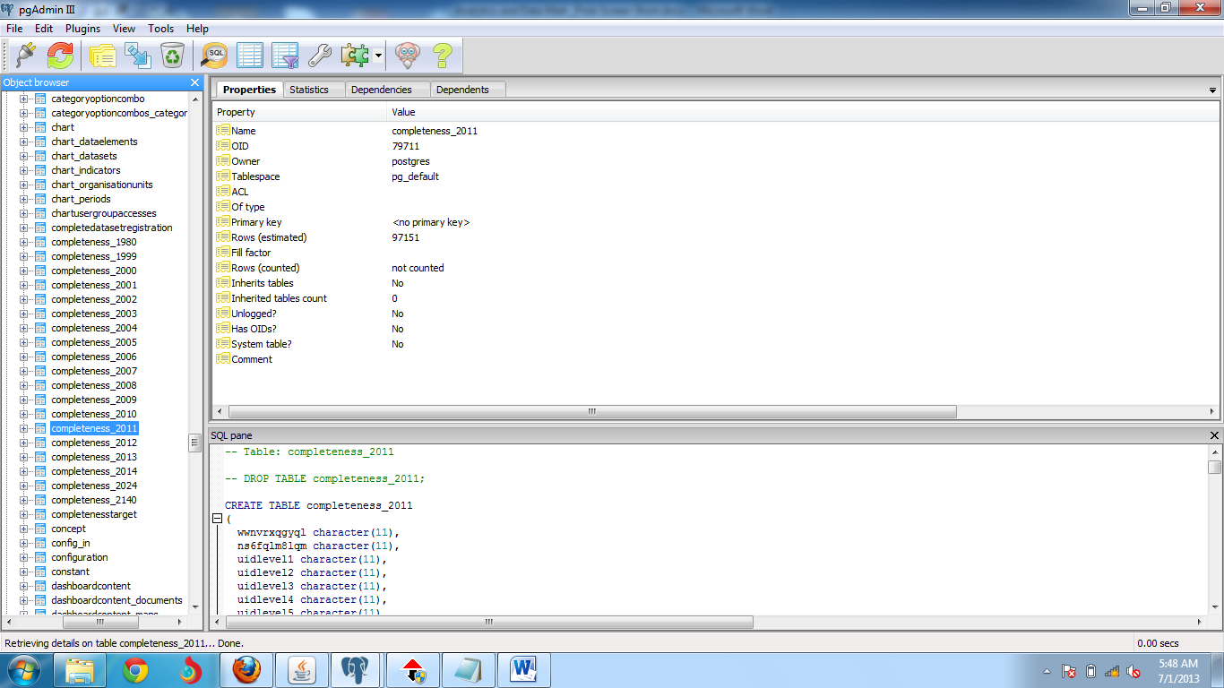
Table: Change in database, new table completeness_1979 to completeness_1940
And in log bug is as follows:
* INFO 2013-06-30 23:16:10,361 [Level: INFO, category: DATAMART, time: Sun Jun
30 23:16:10 BDT 2013, message: Loading indicators] (InMemoryNotifier.java [taskS
cheduler-1])
* INFO 2013-06-30 23:16:10,364 Exploded indicator expressions: 0:33:34.190 (Clo
ck.java [taskScheduler-1])
* INFO 2013-06-30 23:16:10,364 [Level: INFO, category: DATAMART, time: Sun Jun
30 23:16:10 BDT 2013, message: Loading data elements] (InMemoryNotifier.java [ta
skScheduler-1])
* INFO 2013-06-30 23:17:51,356 Retrieved operands: 6880: 0:35:15.182 (Clock.jav
a [taskScheduler-1])
* INFO 2013-06-30 23:17:51,356 [Level: INFO, category: DATAMART, time: Sun Jun
30 23:17:51 BDT 2013, message: Loading periods] (InMemoryNotifier.java [taskSche
duler-1])
* INFO 2013-06-30 23:17:51,478 Number of periods: 10: 0:35:15.303 (Clock.java [
taskScheduler-1])
* INFO 2013-06-30 23:17:51,478 [Level: INFO, category: DATAMART, time: Sun Jun
30 23:17:51 BDT 2013, message: Filtering data elements without data] (InMemoryNo
tifier.java [taskScheduler-1])
* INFO 2013-07-01 00:09:28,675 Number of operands with data: 6284, Mem Total in
JVM: 494 Free in JVM: 120 Max Limit: 494: 1:26:52.501 (Clock.java [taskSchedule
r-1])
* INFO 2013-07-01 00:09:28,676 [Level: INFO, category: DATAMART, time: Mon Jul
01 00:09:28 BDT 2013, message: Populating crosstabulation table] (InMemoryNotifi
er.java [taskScheduler-1])
Exception in thread "org.springframework.scheduling.quartz.SchedulerFactoryBean#
1_QuartzSchedulerThread" Exception in thread "http-apr-8085-exec-8" Exception in
thread "ContainerBackgroundProcessor[StandardEngine[Catalina]]" java.lang.OutOf
MemoryError: Java heap space
java.lang.OutOfMemoryError: Java heap space
java.lang.OutOfMemoryError: Java heap space
at java.util.Arrays.copyOfRange(Unknown Source)
at java.lang.String.<init>(Unknown Source)
at java.util.Properties.loadConvert(Unknown Source)
at java.util.Properties.load0(Unknown Source)
at java.util.Properties.load(Unknown Source)
at java.util.PropertyResourceBundle.<init>(Unknown Source)
at java.util.ResourceBundle$Control.newBundle(Unknown Source)
at java.util.ResourceBundle.loadBundle(Unknown Source)
at java.util.ResourceBundle.findBundle(Unknown Source)
at java.util.ResourceBundle.getBundleImpl(Unknown Source)
at java.util.ResourceBundle.getBundle(Unknown Source)
at org.hisp.dhis.i18n.resourcebundle.DefaultResourceBundleManager.getGlo
balResourceBundle(DefaultResourceBundleManager.java:116)
at org.hisp.dhis.i18n.DefaultI18nManager.getGlobalResourceBundle(Default
I18nManager.java:105)
at org.hisp.dhis.i18n.DefaultI18nManager.getI18n(DefaultI18nManager.java
:70)
at org.hisp.dhis.interceptor.I18nInterceptor.intercept(I18nInterceptor.j
ava:90)
at com.opensymphony.xwork2.DefaultActionInvocation.invoke(DefaultActionI
nvocation.java:249)
at com.opensymphony.xwork2.interceptor.ParametersInterceptor.doIntercept
(ParametersInterceptor.java:211)
at com.opensymphony.xwork2.interceptor.MethodFilterInterceptor.intercept
(MethodFilterInterceptor.java:98)
at com.opensymphony.xwork2.DefaultActionInvocation.invoke(DefaultActionI
nvocation.java:249)
at com.opensymphony.xwork2.interceptor.StaticParametersInterceptor.inter
cept(StaticParametersInterceptor.java:190)
at com.opensymphony.xwork2.DefaultActionInvocation.invoke(DefaultActionI
nvocation.java:249)
at org.hisp.dhis.interceptor.ExceptionInterceptor.intercept(ExceptionInt
erceptor.java:109)
at com.opensymphony.xwork2.DefaultActionInvocation.invoke(DefaultActionI
nvocation.java:249)
at org.apache.struts2.impl.StrutsActionProxy.execute(StrutsActionProxy.j
ava:54)
at org.apache.struts2.dispatcher.Dispatcher.serviceAction(Dispatcher.jav
a:510)
at org.apache.struts2.dispatcher.FilterDispatcher.doFilter(FilterDispatc
her.java:432)
at org.apache.catalina.core.ApplicationFilterChain.internalDoFilter(Appl
icationFilterChain.java:243)
at org.apache.catalina.core.ApplicationFilterChain.doFilter(ApplicationF
ilterChain.java:210)
at org.springframework.security.web.FilterChainProxy$VirtualFilterChain.
doFilter(FilterChainProxy.java:330)
at org.springframework.security.web.access.intercept.FilterSecurityInter
ceptor.invoke(FilterSecurityInterceptor.java:118)
at org.springframework.security.web.access.intercept.FilterSecurityInter
ceptor.doFilter(FilterSecurityInterceptor.java:84)
at org.springframework.security.web.FilterChainProxy$VirtualFilterChain.
doFilter(FilterChainProxy.java:342)
* ERROR 2013-07-01 00:51:08,516 Unexpected error occurred in scheduled task. (Ta
skUtils.java [taskScheduler-1])
java.lang.RuntimeException: Exception during execution
at org.hisp.dhis.system.util.ConcurrentUtils.waitForCompletion(Concurren
tUtils.java:54)
at org.hisp.dhis.datamart.engine.DefaultDataMartEngine.export(DefaultDat
aMartEngine.java:329)
at org.hisp.dhis.datamart.engine.DefaultDataMartEngine.export(DefaultDat
aMartEngine.java:202)
at sun.reflect.NativeMethodAccessorImpl.invoke0(Native Method)
at sun.reflect.NativeMethodAccessorImpl.invoke(Unknown Source)
at sun.reflect.DelegatingMethodAccessorImpl.invoke(Unknown Source)
at java.lang.reflect.Method.invoke(Unknown Source)
at org.springframework.aop.support.AopUtils.invokeJoinpointUsingReflecti
on(AopUtils.java:317)
at org.springframework.aop.framework.ReflectiveMethodInvocation.invokeJo
inpoint(ReflectiveMethodInvocation.java:183)
at org.springframework.aop.framework.ReflectiveMethodInvocation.proceed(
ReflectiveMethodInvocation.java:150)
at org.springframework.transaction.interceptor.TransactionInterceptor.in
voke(TransactionInterceptor.java:110)
at org.springframework.aop.framework.ReflectiveMethodInvocation.proceed(
ReflectiveMethodInvocation.java:172)
at org.springframework.aop.aspectj.MethodInvocationProceedingJoinPoint.p
roceed(MethodInvocationProceedingJoinPoint.java:80)
at org.amplecode.quick.StatementInterceptor.intercept(StatementIntercept
or.java:71)
at sun.reflect.NativeMethodAccessorImpl.invoke0(Native Method)
at sun.reflect.NativeMethodAccessorImpl.invoke(Unknown Source)
at sun.reflect.DelegatingMethodAccessorImpl.invoke(Unknown Source)
at java.lang.reflect.Method.invoke(Unknown Source)
at org.springframework.aop.aspectj.AbstractAspectJAdvice.invokeAdviceMet
hodWithGivenArgs(AbstractAspectJAdvice.java:621)
at org.springframework.aop.aspectj.AbstractAspectJAdvice.invokeAdviceMet
hod(AbstractAspectJAdvice.java:610)
at org.springframework.aop.aspectj.AspectJAroundAdvice.invoke(AspectJAro
undAdvice.java:65)
at org.springframework.aop.framework.ReflectiveMethodInvocation.proceed(
ReflectiveMethodInvocation.java:172)
at org.springframework.aop.interceptor.ExposeInvocationInterceptor.invok
e(ExposeInvocationInterceptor.java:91)
at org.springframework.aop.framework.ReflectiveMethodInvocation.proceed(
ReflectiveMethodInvocation.java:172)
at org.springframework.aop.framework.JdkDynamicAopProxy.invoke(JdkDynami
cAopProxy.java:204)
at $Proxy135.export(Unknown Source)
at org.hisp.dhis.scheduling.DataMartTask.run(DataMartTask.java:113)
at org.hisp.dhis.scheduling.ScheduledTasks.run(ScheduledTasks.java:59)
at org.springframework.scheduling.support.DelegatingErrorHandlingRunnabl
e.run(DelegatingErrorHandlingRunnable.java:53)
at java.util.concurrent.Executors$RunnableAdapter.call(Unknown Source)
at java.util.concurrent.FutureTask$Sync.innerRun(Unknown Source)
at java.util.concurrent.FutureTask.run(Unknown Source)
at java.util.concurrent.ScheduledThreadPoolExecutor$ScheduledFutureTask.
access$201(Unknown Source)
at java.util.concurrent.ScheduledThreadPoolExecutor$ScheduledFutureTask.
run(Unknown Source)
at java.util.concurrent.ThreadPoolExecutor.runWorker(Unknown Source)
at java.util.concurrent.ThreadPoolExecutor$Worker.run(Unknown Source)
at java.lang.Thread.run(Unknown Source)
Caused by: java.util.concurrent.ExecutionException: java.lang.RuntimeException:
Failed to add objects
at java.util.concurrent.FutureTask$Sync.innerGet(Unknown Source)
at java.util.concurrent.FutureTask.get(Unknown Source)
at org.hisp.dhis.system.util.ConcurrentUtils.waitForCompletion(Concurren
tUtils.java:50)
... 36 more
Caused by: java.lang.RuntimeException: Failed to add objects
at org.amplecode.quick.batchhandler.AbstractBatchHandler.addObject(Abstr
actBatchHandler.java:210)
at org.hisp.dhis.datamart.crosstab.DefaultCrossTabService.populateCrossT
abTable(DefaultCrossTabService.java:170)
at sun.reflect.NativeMethodAccessorImpl.invoke0(Native Method)
at sun.reflect.NativeMethodAccessorImpl.invoke(Unknown Source)
at sun.reflect.DelegatingMethodAccessorImpl.invoke(Unknown Source)
at java.lang.reflect.Method.invoke(Unknown Source)
at org.springframework.aop.support.AopUtils.invokeJoinpointUsingReflecti
on(AopUtils.java:317)
at org.springframework.aop.framework.ReflectiveMethodInvocation.invokeJo
inpoint(ReflectiveMethodInvocation.java:183)
at org.springframework.aop.framework.ReflectiveMethodInvocation.proceed(
ReflectiveMethodInvocation.java:150)
at org.springframework.aop.interceptor.AsyncExecutionInterceptor$1.call(
AsyncExecutionInterceptor.java:83)
at java.util.concurrent.FutureTask$Sync.innerRun(Unknown Source)
at java.util.concurrent.FutureTask.run(Unknown Source)
... 1 more
Caused by: java.sql.SQLException: java.lang.OutOfMemoryError: Java heap space
at org.hsqldb.jdbc.Util.sqlException(Unknown Source)
at org.hsqldb.jdbc.Util.sqlException(Unknown Source)
at org.hsqldb.jdbc.JDBCStatement.fetchResult(Unknown Source)
at org.hsqldb.jdbc.JDBCStatement.executeUpdate(Unknown Source)
at org.amplecode.quick.batchhandler.AbstractBatchHandler.addObject(Abstr
actBatchHandler.java:191)
... 12 more
Caused by: org.hsqldb.HsqlException: java.lang.OutOfMemoryError: Java heap space

at org.hsqldb.error.Error.error(Unknown Source)
at org.hsqldb.result.Result.newErrorResult(Unknown Source)
at org.hsqldb.StatementDMQL.execute(Unknown Source)
at org.hsqldb.Session.executeCompiledStatement(Unknown Source)
at org.hsqldb.Session.executeDirectStatement(Unknown Source)
at org.hsqldb.Session.execute(Unknown Source)
... 15 more
Caused by: java.lang.OutOfMemoryError: Java heap space
