Single Event without Registration Step -1: Edit the Program stage.
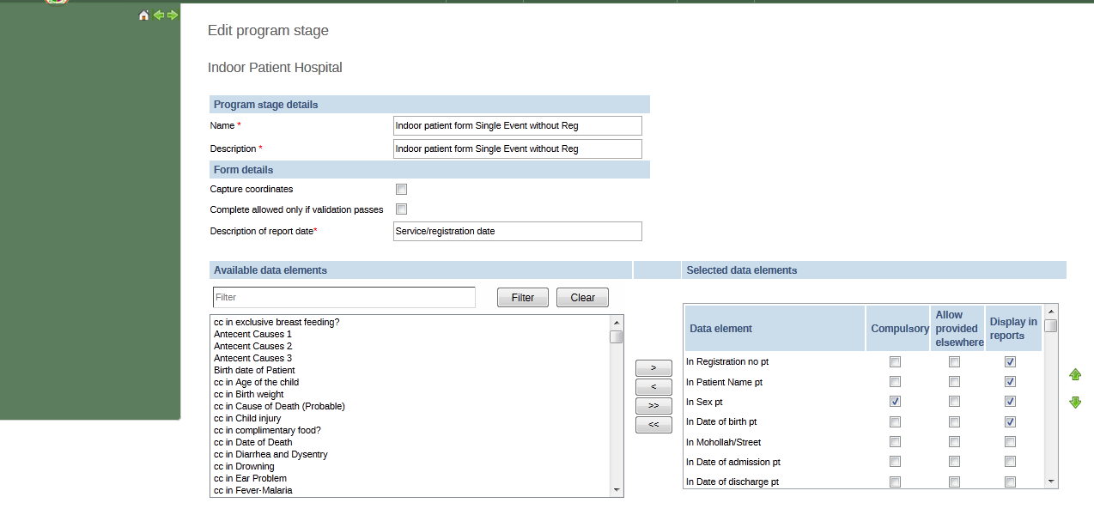
Step 2: Service-> Individual Record -> Single event without registration.
After editing the program stage the data entry form is not coming.
Fig : Data entry form is not showing.

Change in Database: Capturecoord column is not updating as FALSE.

