In our live server the point layers are not displaying the facilities, instead it gives us the message coordinates could not be loaded.

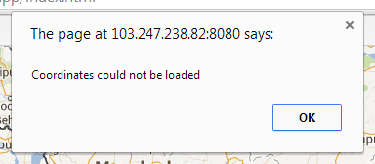
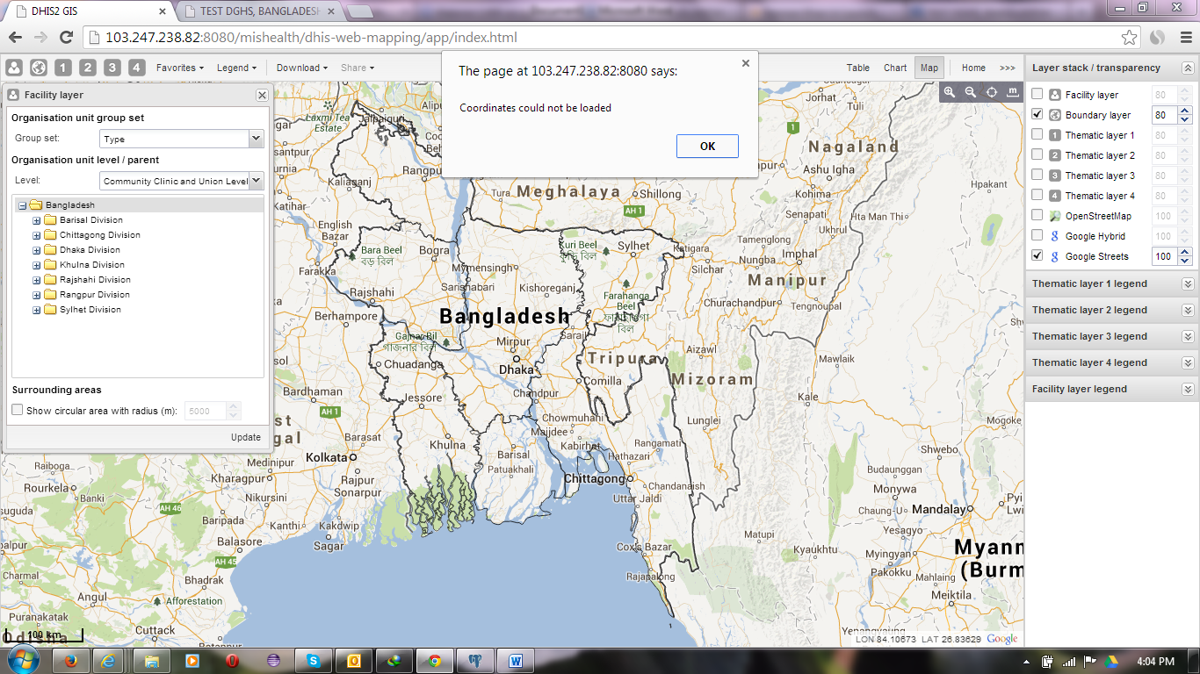
The coordinated of the facility layers are in the database (12185 out of 26103).
The test server has the same data up to August. But the facility layer is working properly in the test servers.
The organisationunit table has the same data. I attached the part of a log file. Can you please suggests how can I solve this problem.

