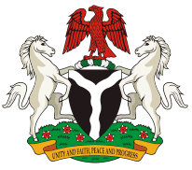

NATIONAL CONFERENCE ON HEALTH INFORMATION TECHNOLOGY
under the auspices of the FEDERAL MINISTRY OF HEALTH and in collaboration with
National Agency for the Control of AIDS, National Health Insurance Scheme ….

Abuja, FCT. 1st – 3rd November 2011

Theme: Towards ONE harmonized health data management system.

Objectives:
- Review computer applications for Health Information System (HIS) in use in Nigeria and document their level of use and availability of in-country support (capacity for maintenance, revision and upgrade).
- Discuss the inter-operability between the HIS applications in use in Nigeria.
- Discuss the Health Information Technology component of the Nigeria e-Health Strategy and the role of Public Private Partnership in its implementation.

Target Audience:
- Policy makers and IT experts in Health Information Systems in Federal and State Ministries, Departments and Agencies.
- Software developers and vendors of Health Information Applications.
- Manufacturers and Providers of wired and wireless network infrastructure and equipment (including mobile networks).

Participation by invitation.

Request for invitation and further information should be sent to:
nhit.conference@fshdev.org; akubuiro_ada@yahoo.com or reginaony@yahoo.com.

Coordination by:
FHSD, 326 Adeyemo Akapo Street, Omole Phase I, Ikeja, Lagos State.

